# Unit 11: Semiconductors and Diodes

**Course:** Electrical Instrumentation (Phase 2)

**Objective:** To provide a complete theoretical and practical understanding of semiconductor physics, diode operation, and circuit applications.

## Chapter 1: The Physics of Matter and Electricity

### 1.1 Introduction to Atomic Theory

To understand how a semiconductor works, one must first understand the fundamental building blocks of matter. All electronics rely on the manipulation of subatomic particles.

**The Structure of the Atom**

Everything in the physical universe is made of atoms. An atom is the smallest unit of matter that retains the properties of a chemical element. It consists of two main regions:

1. **The Nucleus:** Located at the center of the atom, the nucleus is extremely dense and contains two types of particles:
   * **Protons:** These carry a **Positive (+)** electrical charge. The number of protons determines the atomic number and identity of the element (e.g., Carbon has 6 protons, Silicon has 14).
   * **Neutrons:** These carry **No Charge (Neutral)**. They add mass to the atom but do not affect its electrical charge.
2. **The Electron Cloud:** Orbiting the nucleus are high-speed particles called **Electrons**.
   * **Electrons:** These carry a **Negative (-)** electrical charge. They are the primary carriers of electricity in solids.

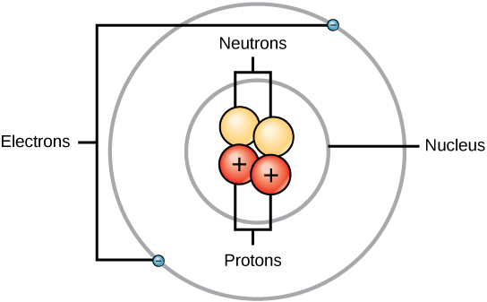

**Electrical Neutrality**

In a stable, neutral atom, the number of negatively charged electrons orbiting the nucleus is exactly equal to the number of positively charged protons inside the nucleus. The charges cancel each other out, resulting in a net charge of zero.

* *Key Definition:* An **Ion** is an atom that is "unbalanced." It has either gained or lost an electron, resulting in a net electrical charge.

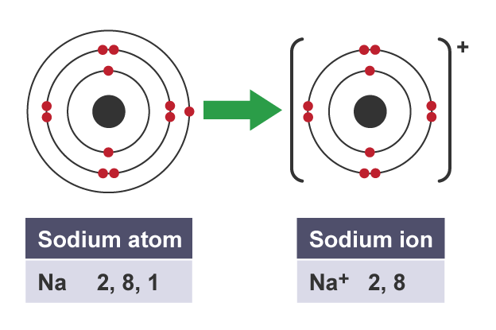

### 1.2 Electron Shells and Energy Bands

Electrons do not orbit randomly; they occupy specific energy levels or "shells" at fixed distances from the nucleus.

* **The Valence Shell:** The outermost shell of an atom is the most critical for electronics. It is called the **Valence Shell**. The electrons located here are loosely bound compared to inner electrons and are the only ones capable of participating in chemical bonding or electrical flow.

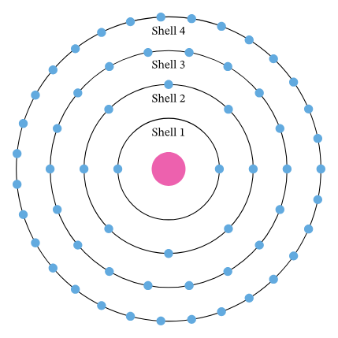

* **The Octet Rule (Conditional Completeness):** Atoms inherently seek stability. The most stable state for an atom is to have its valence shell completely full. For most elements used in electronics, a "full" shell contains **8 electrons**.
  + An atom with 8 valence electrons is chemically inert and very stable (e.g., Neon gas).
  + An atom with fewer than 8 will try to gain, lose, or share electrons to reach that magic number. This drive to reach 8 is what allows semiconductors to work.  
      
    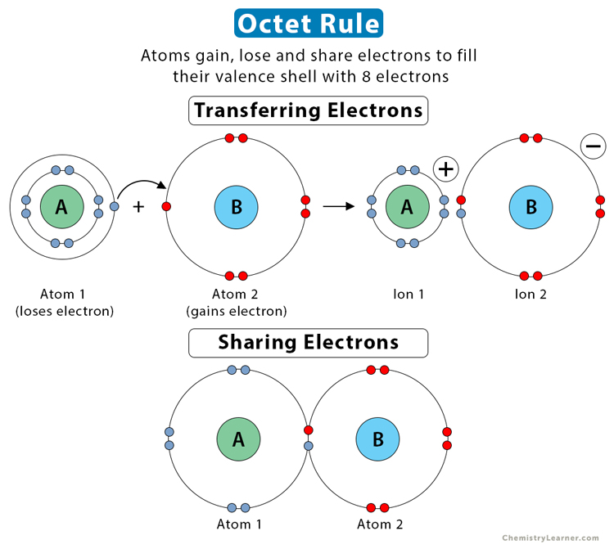

### 1.3 Classification of Materials

Based on their valence shell configuration, all materials are classified into three electrical categories:

1. **Conductors**
   * *Characteristics:* Conductors allow electrical current to flow with very little resistance.
   * *Atomic Structure:* They have very few valence electrons—typically **1, 2, or 3**. Because the shell is far from full, these electrons are very loosely held by the nucleus. A small external force (Voltage/EMF) can easily knock them free, creating current.
   * *Examples:*
     + **Copper (Cu):** The industry standard for wiring.
     + **Gold (Au):** Excellent for contacts (doesn't corrode).
     + **Aluminium:** Used in overhead power lines.
2. **Insulators**
   * *Characteristics:* Insulators oppose the flow of electrical current. They have very high resistance.
   * *Atomic Structure:* They have a nearly full valence shell—typically **5, 6, 7, or 8** electrons. These atoms hold onto their electrons tightly to maintain stability, making it very difficult to knock them free.
   * *Examples:* PVC, Glass, Mica, Rubber, Ceramic.
   * *Note:* A good insulator is characterized by having high resistance.
3. **Semiconductors**
   * *Characteristics:* Materials that are neither good conductors nor good insulators. Their conductivity can be precisely controlled by external factors like temperature, light, or chemical modification.
   * *Atomic Structure:* They have exactly **4 valence electrons**. This places them right in the middle of the conductivity spectrum.
   * *Examples:*
     + **Silicon (Si):** The most widely used semiconductor material in the world.
     + **Germanium (Ge):** An early semiconductor material, still used in specific high-frequency applications.

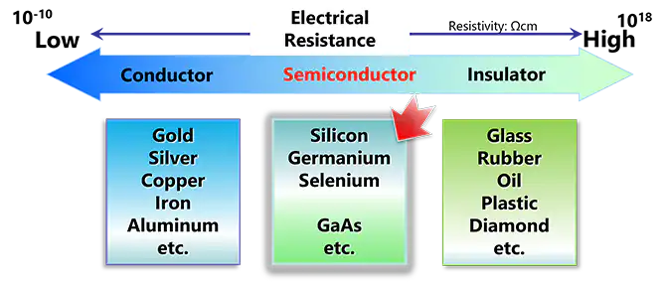

## Chapter 2: Semiconductor Crystal Structure and Doping

### 2.1 Intrinsic Semiconductors (Pure Silicon)

A pure block of silicon is known as an **Intrinsic Semiconductor**.

* **Covalent Bonding:** Since silicon atoms have 4 valence electrons but want 8, they form a crystal lattice structure. Each silicon atom shares one of its valence electrons with four distinct neighbors.
* **The Result:** By sharing, every atom "feels" like it has a full shell of 8 electrons. This creates a very rigid, stable structure where electrons are locked in place.
* **Conductivity:** At absolute zero temperature, pure silicon acts as a perfect insulator because no electrons are free to move. At room temperature, thermal energy knocks a few loose, but not enough to carry useful current.

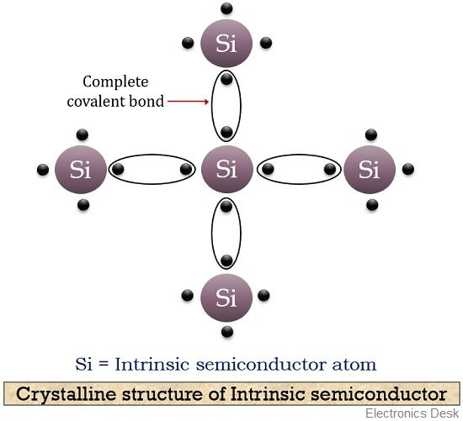

### 2.2 The Doping Process

To make silicon useful for electronics, we must artificially increase its conductivity. This is done by adding controlled amounts of impurities to the pure crystal. This process is called **Doping**.

Doping creates two distinct types of semiconductor material: **N-Type** and **P-Type**.

#### A. N-Type Material (Negative Type)

* **The Impurity:** To create N-Type silicon, we dope it with a **Pentavalent** element.
  + *Pentavalent* means the atom has **5 valence electrons**.
  + *Common Impurities:* Arsenic (As), Phosphorus (P), Antimony (Sb).
* **The Mechanism:**
  1. The pentavalent atom enters the silicon crystal lattice.
  2. Four of its valence electrons form covalent bonds with the surrounding silicon atoms.
  3. The **5th electron** has no one to bond with. It is left "hanging" loosely.
* **The Result:** This extra electron requires almost no energy to break free. It becomes a **Free Electron**.
* **Majority Carriers:** Since we have added extra electrons (negative charge), **Electrons** are the majority charge carriers in N-Type material.
* *Memory Aid:* **N**-Type = **N**egative Carriers (Electrons).

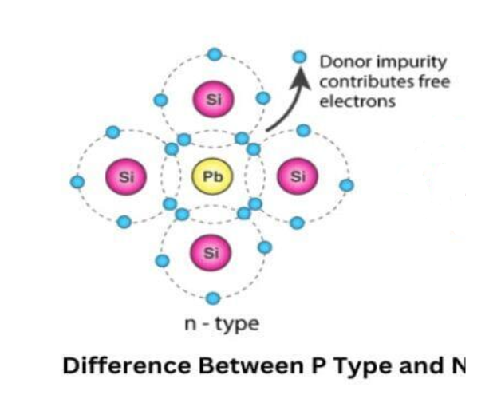

#### B. P-Type Material (Positive Type)

* **The Impurity:** To create P-Type silicon, we dope it with a **Trivalent** element.
  + *Trivalent* means the atom has only **3 valence electrons**.
  + *Common Impurities:* Boron (B), Gallium (Ga), Indium (In).
* **The Mechanism:**
  1. The trivalent atom enters the lattice.
  2. Its three electrons form bonds with three silicon neighbors.
  3. However, the fourth silicon neighbor has nothing to bond with. This creates a "vacancy" or a missing electron in the lattice.
* **The "Hole":** This vacancy is called a **Hole**. In semiconductor physics, a hole is treated as a specific particle with a **Positive charge**.
* **Majority Carriers:** Since we have created gaps for electrons to fall into, **Holes** are the majority charge carriers in P-Type material.
* *Memory Aid:* **P**-Type = **P**ositive Carriers (Holes).

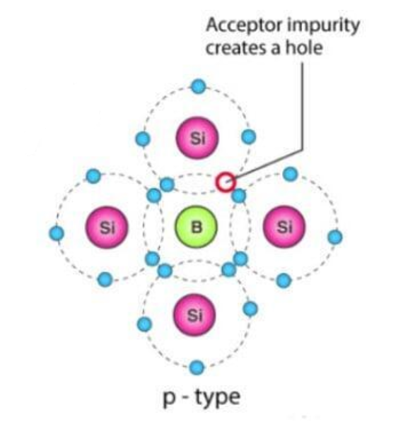

## Chapter 3: The PN Junction (The Diode)

The magic of electronics happens when we fuse a block of P-Type material to a block of N-Type material. This boundary is called the **PN Junction**.

### 3.1 Formation of the Depletion Region

1. **Diffusion:** At the instant the two materials touch, the free electrons in the N-side look across the border and see the holes (vacancies) in the P-side. Opposites attract. The electrons rush across the junction to fill the holes.
2. **Recombination:** When an electron falls into a hole, they effectively cancel each other out electrically. The free carriers disappear.
3. **The Ion Barrier:**
   * When the N-side loses electrons, the atoms left behind become **Positive Ions**.
   * When the P-side gains electrons, the atoms there become **Negative Ions**.
4. **The Depletion Layer:** This region near the junction is now "depleted" of any free carriers (no free electrons, no holes). It is populated only by these static ions. This zone is called the **Depletion Region** or **Depletion Layer**.
5. **The Barrier Potential:** The positive ions on the N-side and negative ions on the P-side create an electric field (voltage) that acts like a wall. This "Barrier Potential" prevents any more electrons from crossing over.
   * **Silicon Diode Barrier:** Approx **0.6 Volts** to **0.7 Volts**.
   * **Germanium Diode Barrier:** Approx. **0.3 Volts**.

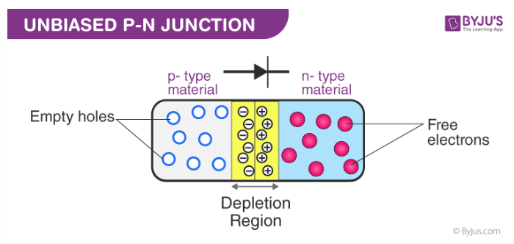

### 3.2 Biasing the Diode

A standard diode is a two-terminal device. The P-side is called the **Anode** (A) and the N-side is called the **Cathode** (K). Biasing refers to applying an external voltage to these terminals.

#### Forward Bias (Current Flows)

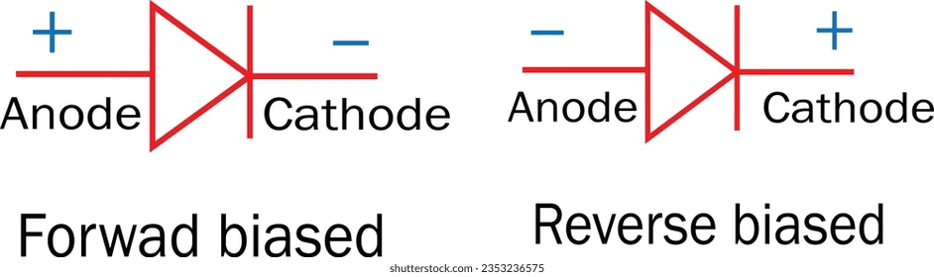

* **Connection:** Connect the **Positive (+)** supply to the **Anode** and the **Negative (-)** supply to the **Cathode**.
* **Operation:**
  1. The positive terminal repels the holes in the P-material, pushing them towards the junction.
  2. The negative terminal repels the electrons in the N-material, pushing them towards the junction.
  3. This pressure squeezes the Depletion Region.
* **Result:** The depletion layer **Decreases** (narrows).
* **Conduction:** Once the external voltage exceeds the barrier potential (0.6V), the door bursts open. Current flows freely through the diode. The diode acts like a closed switch.

#### Reverse Bias (Current Blocked)



* **Connection:** Connect the **Negative (-)** supply to the **Anode** and the **Positive (+)** supply to the **Cathode**.
* **Operation:**
  1. The negative terminal attracts the holes in the P-material *away* from the junction.
  2. The positive terminal attracts the electrons in the N-material *away* from the junction.
  3. This pulls the Depletion Region apart.
* **Result:** The depletion layer **Increases** (widens).
* **Conduction:** The barrier becomes insurmountable. No current flows (except for a microscopic "leakage current" usually ignored in basic circuits). The diode acts like an open switch.

## Chapter 4: Diode Characteristics and Symbols

### 4.1 The V-I Characteristic Curve

We use a graph called the V-I (Voltage-Current) curve to describe how a diode behaves.

* **The Knee Voltage:** In the forward region, current remains near zero until the voltage hits 0.6V (Silicon). At this point, the curve shoots upwards sharply. This 0.6V point is the "Knee."
* **Forward Voltage Drop (Vf):** When conducting, a silicon diode "steals" about 0.6V to 0.7V from the supply. This is crucial for calculations.
* **Breakdown Region:** In reverse bias, if the voltage gets too high (e.g., 100V, 400V depending on the model), the diode will fail and conduct current backwards. This is often destructive for standard diodes.

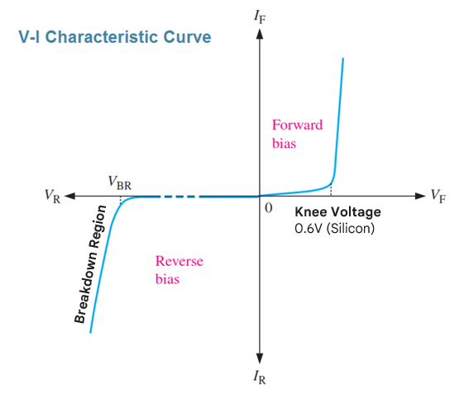

**Breakdown Region**

**Knee Voltage**

0.6V (Silicon)

### 4.2 Key Ratings and Definitions

1. **Peak Inverse Voltage (PIV):** This is the **Maximum voltage a diode can handle in reverse bias** without being destroyed. If you put 50V across a diode rated for 25V PIV, it will fail.
2. **Turn-On Voltage:** The voltage at which the diode begins to conduct (0.6V for Si).
3. **Maximum Forward Current (If):** The maximum current the diode can conduct continuously without overheating and burning out.

### 4.3 Symbols and Physical Identification

* **Graphical Symbol:**

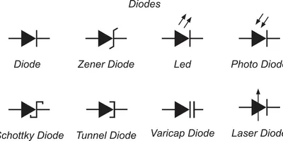

* + The triangle represents the **Anode (+)**.
  + The straight line (bar) represents the **Cathode (-)**.
  + The arrow points in the direction of conventional current flow.
* **Physical Component:**

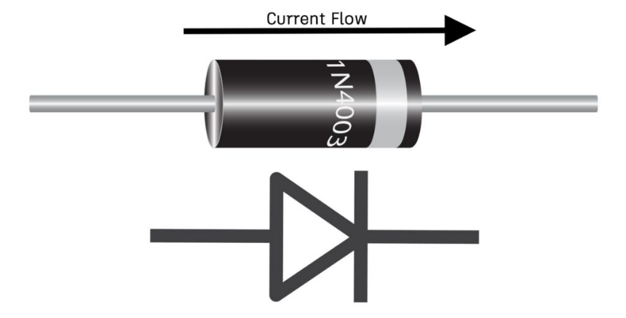

* + Standard plastic diodes have a silver or black band painted on one end.
  + **The Band indicates the Cathode (-)**.
* **Testing with a Multimeter:**
  + Set the meter to "Diode Check" mode (symbol is a diode).
  + **Good Diode:**
    - Forward (Red to Anode): Reads ~0.5V to 0.7V.
    - Reverse (Red to Cathode): Reads "OL" (Open Loop / Infinite).
  + **Bad Diode (Short):** Beeps or reads 0V in both directions.
  + **Bad Diode (Open):** Reads "OL" in both directions.

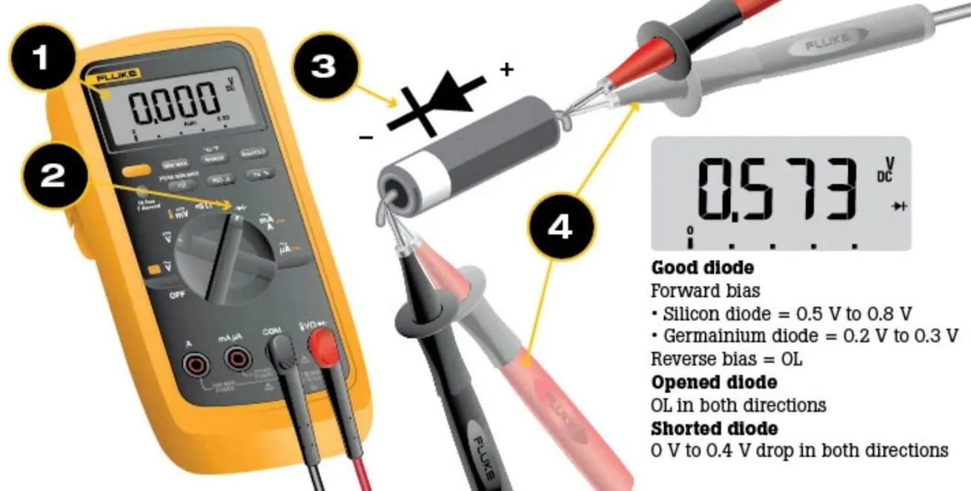

A multimeter’s Diode Test mode produces a small voltage between test leads. The multimeter then displays the voltage drop when the test leads are connected across a diode when forward-biased. The Diode Test procedure is conducted as follows:

* 1. Make certain a) all power to the circuit is OFF and b) no voltage exists at the diode. Voltage may be present in the circuit due to charged capacitors. If so, the capacitors need to be discharged. Set the multimeter to measure ac or dc voltage as required.
  2. Turn the dial (rotary switch) to Diode Test mode. It may share a space on the dial with another function.
  3. Connect the test leads to the diode. Record the measurement displayed.
  4. Reverse the test leads. Record the measurement displayed.

## Chapter 5: Rectification (AC to DC Applications)

One of the primary uses of diodes is **Rectification**: the process of converting Alternating Current (AC) into Direct Current (DC).

### 5.1 Half-Wave Rectification

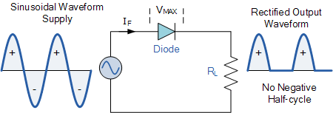

* **Circuit Construction:** A single diode is placed in series with an AC supply and a load.
* **Operation:**
  + **Positive Half-Cycle:** The diode is Forward Biased. Current flows to the load.
  + **Negative Half-Cycle:** The diode is Reverse Biased. Current is blocked.
* **Output Waveform:** You get a series of pulses with gaps in between. It utilizes only 50% of the available power.
* **Ripple Frequency:** The output pulses occur at the same frequency as the input supply.
  + *Example:* 50Hz Supply = **50Hz Ripple**.

### 5.2 Full-Wave Bridge Rectification

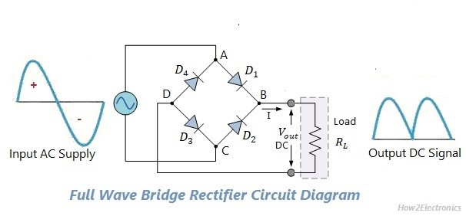

* **Circuit Construction:** Uses **4 Diodes** arranged in a "Diamond" bridge configuration.
* **Operation:**
  + **Positive Half-Cycle:** Diodes D1 and D3 conduct, steering current through the load.
  + **Negative Half-Cycle:** Diodes D2 and D4 conduct, steering current through the load *in the same direction*.
* **Output Waveform:** The negative cycles are flipped up to become positive. There are no gaps in the output.
* **Ripple Frequency:** Since there are two pulses for every one AC cycle, the ripple frequency is doubled.
  + *Example:* 50Hz Supply = **100Hz Ripple**.

### 5.3 Smoothing

|  |  |
| --- | --- |
| **Half Wave** |  |
| **Full Wave** |  |

The output from a rectifier is bumpy "pulsating DC." To make it suitable for electronics (like charging a phone), it must be smooth.

* **The Component:** A **Capacitor** is placed in parallel with the load.
* **Action:** The capacitor charges up to the peak voltage. When the rectifier voltage drops, the capacitor discharges into the load, maintaining the voltage level and "filling in the dips."
* **Ripple Voltage:** The small variation that remains after smoothing is called the Ripple Voltage.

## Chapter 6: Special Purpose Diodes

### 6.1 The Zener Diode



* **Symbol:** A diode symbol where the cathode bar has "bent" ends, resembling a letter 'Z'.
* **Principle of Operation:** Unlike normal diodes, Zener diodes are designed to work in the **Reverse Breakdown Region**.
  + If you apply a reverse voltage higher than the "Zener Voltage" (Vz), the diode conducts current backwards.
  + Crucially, while conducting, it maintains a **constant voltage** across its terminals.
* **Application:** **Voltage Regulation** (Stabilization).
  + *Example:* A 5.1V Zener connected in parallel with a sensitive chip will ensure the chip never sees more than 5.1V, even if the supply spikes to 12V.

### 6.2 The Light Emitting Diode (LED)



* **Symbol:** A standard diode symbol with two small arrows pointing **away** from the component, indicating light emission.
* **Principle of Operation:** When forward biased, electrons and holes recombine at the junction. In specific materials (like Gallium Arsenide), this energy is released as photons of light (Electroluminescence).
* **Polarity Identification:**
  + **Long Leg:** **Anode (+)** (Positive).
  + **Short Leg:** **Cathode (-)** (Negative).
  + **Flat Edge on Body:** Indicates the Cathode side.
* **Current Limiting:** LEDs have very low internal resistance. If connected directly to a battery, they will draw infinite current and burn out instantly. They **must always** have a series resistor to limit the current.

## Chapter 7: Circuit Calculations and Analysis

We you must be proficient in applying Ohm's Law to diode circuits. The Golden Rule is: **Always subtract the Diode Drop (Vf) first.**

### 7.1 Calculation 1: Diode Forward Current

**Scenario:** A DC supply (Vs) is connected in series with a Silicon diode and a Load Resistor (RL). Calculate the current (I).

The Formula:

$$I=\frac{V_{s}-0.6V}{R_{L}}$$

**Worked Example 1:**

* **Given:** Supply = 0.45V, Silicon Diode, Resistor = 10Ω.
* **Analysis:** The supply (0.45V) is *less* than the barrier potential of silicon (0.6V).
* **Result:** The diode cannot turn on. **Current = 0 Amps (None)**.

**Worked Example 2:**

* **Given:** Supply = 6V DC, Silicon Diode, Resistor = 10Ω.
* Step 1: Calculate Voltage across Resistor (VR).
* Step 2: Apply Ohm's Law. $$I=\frac{5.4V}{10Ω}=0.54A$$
* **Answer:** **0.54 Amps**

**Worked Example 3:**

* **Given:** Supply = 10V DC, Silicon Diode, Resistor = 100Ω.
* **Step 1:**

$V_{R}=10V-0.6V=9.4V$.

* **Step 2:**

$I=\frac{9.4V}{100Ω}=0.094A$.

* **Answer:** **0.094 Amps (or 94mA)**.

### 7.2 Calculation 2: LED Series Resistor

**Scenario:** You need to power an LED from a specific voltage supply. You must calculate the correct resistor size to prevent it from blowing up.

The Formula:

$$R=\frac{V_{supply}-V_{LED}}{I_{LED}}$$

**Worked Example:**

* **Given:** Supply = 12V DC. LED Voltage Drop = 2V. Required Current = 30mA (0.030A).
* Step 1: Find the voltage that the resistor must "absorb." $$V_{R}=12V-2V=10V$$
* Step 2: Calculate Resistance. $$R=\frac{10V}{0.030A}=333.33$$
* **Answer:** **333 Ohms**.

### 7.3 Calculation 3: Zener Diode Shunt Resistor

**Scenario:** Designing a simple voltage regulator.

The Formula:

$$R_{s}=\frac{V_{in}-V_{zener}}{I_{load}+I_{zener}}$$

**Explanation:** The resistor must allow enough current to flow to feed the load *plus* enough extra current to keep the Zener diode working in its breakdown region.

## Chapter 8: Thermal Management and Safety

### 8.1 Heat Generation

Electronic components are not 100% efficient. Diodes drop voltage (0.6V). This energy is lost as heat.

* **Power Formula: $P = V ×I$** .
* *Example:* A diode carrying 10 Amps will generate: $0.6V×10A=6\text{ Watts}$ of heat.
* **Thermal Runaway:** If a semiconductor gets too hot, its resistance drops. This causes *more* current to flow, which creates *more* heat. This cycle continues until the component is destroyed.

### 8.2 The Heat Sink

To prevent thermal failure, high-power diodes and transistors are mounted to a **Heat Sink**.

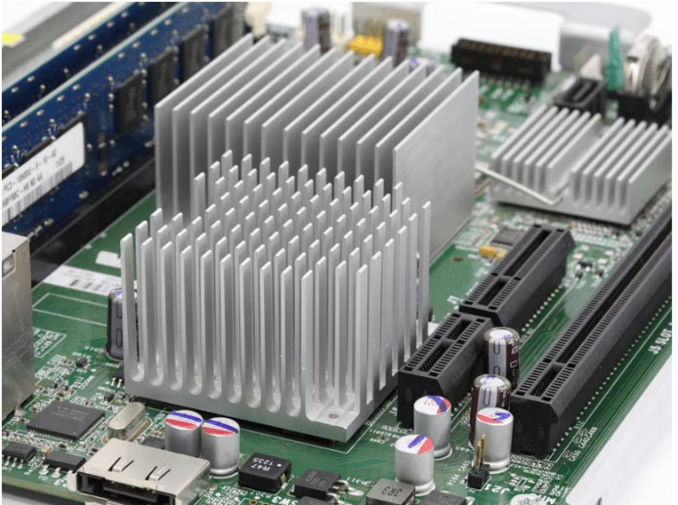

* **Material:** Usually Aluminium or Copper (good thermal conductors).
* **Function:** It increases the surface area of the component, allowing the heat to dissipate (spread out) into the surrounding air much faster.
* **Thermal Paste:** A white paste is often used between the component and the heat sink to ensure good thermal contact by filling microscopic air gaps.

## Chapter 9: Summary of Essential Facts

1. **Materials:**
   * Most widely used semiconductors: **Silicon** and **Germanium**.
   * Unbalanced atom: **Ion**.
   * Valence electrons in Silicon: **4**.
2. **Doping:**
   * **N-Type:** Uses **Pentavalent** impurity (5 electrons). Majority carriers: **Electrons**.
   * **P-Type:** Uses **Trivalent** impurity (3 electrons). Majority carriers: **Holes**.
3. **Diode Operations:**
   * Forward Bias: Anode (+), Cathode (-). Depletion layer **decreases**.
   * Reverse Bias: Anode (-), Cathode (+). Depletion layer **increases**.
   * Silicon Forward Voltage: **0.6 Volts**.
4. **Applications:**
   * Rectifier: Converts AC to DC.
   * Ripple Frequency (Half Wave): **Same** as supply (50Hz).
   * Ripple Frequency (Full Wave): **Double** the supply (100Hz).
   * Zener Diode: Used for **Voltage Stabilization**.
5. **Symbols:**



* + Bar on diode symbol = **Cathode (-)**.
  + LED Positive Leg = **Long Leg**.